1. With rng(2)

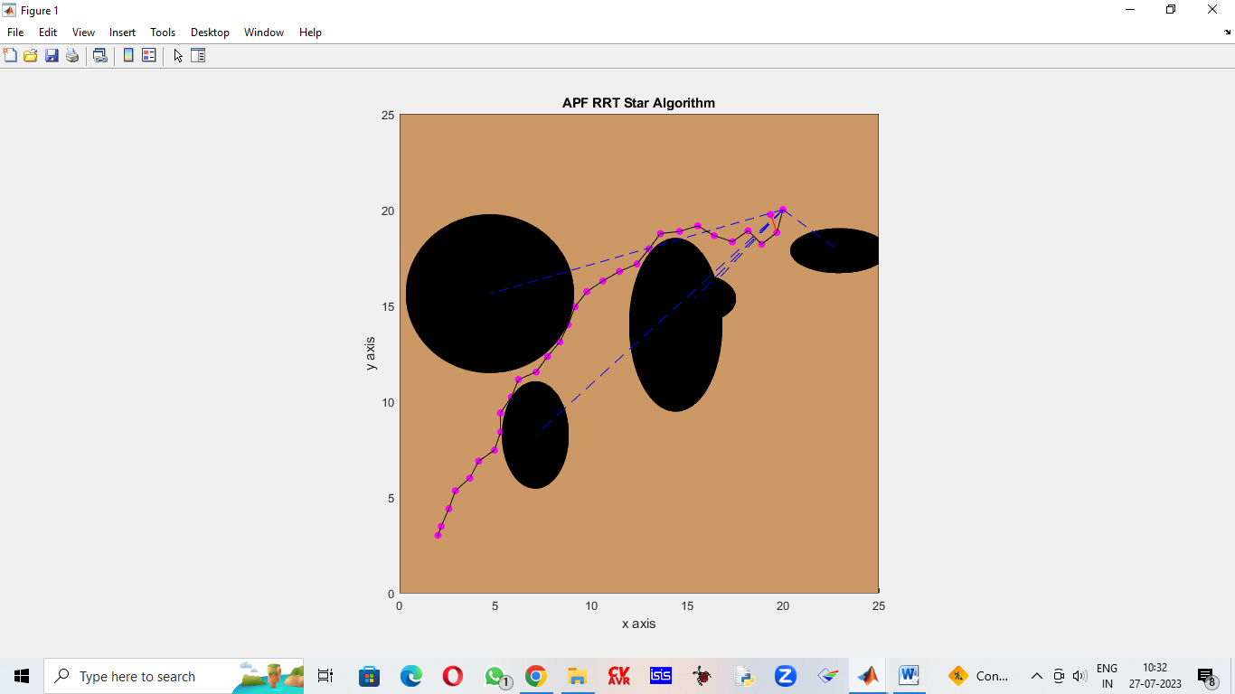

Iterations : 29

Distance Travelled : 28.7349

Time Taken : 9.9897

1. With rng(1)

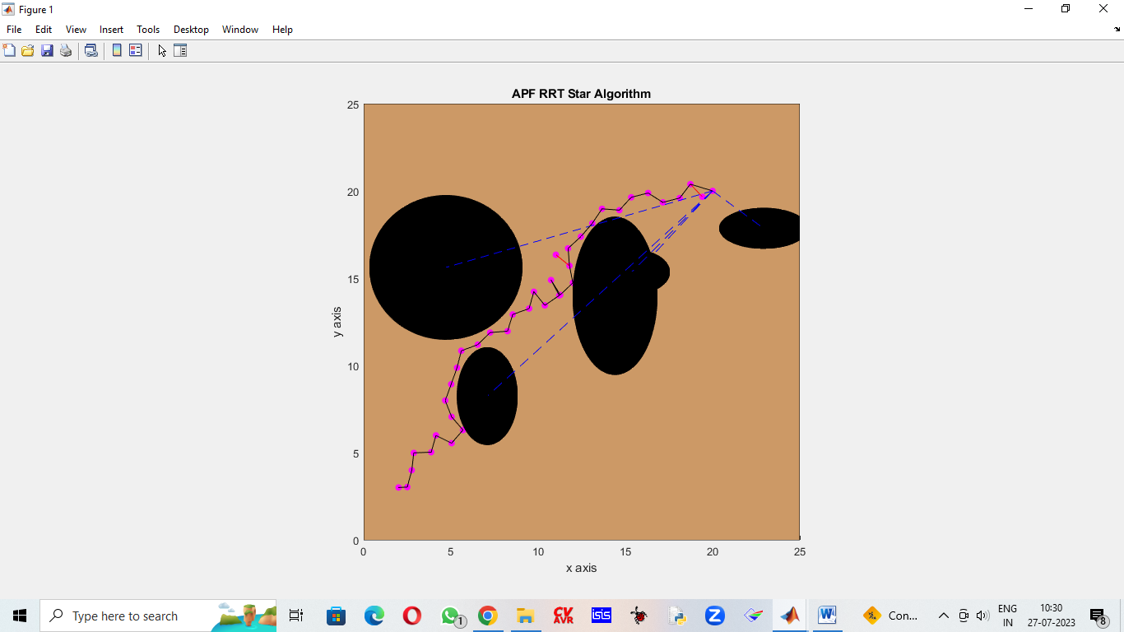

Iterations : 38

Distance Travelled : 34.8314

Time Taken : 19.9804

1. Without rng

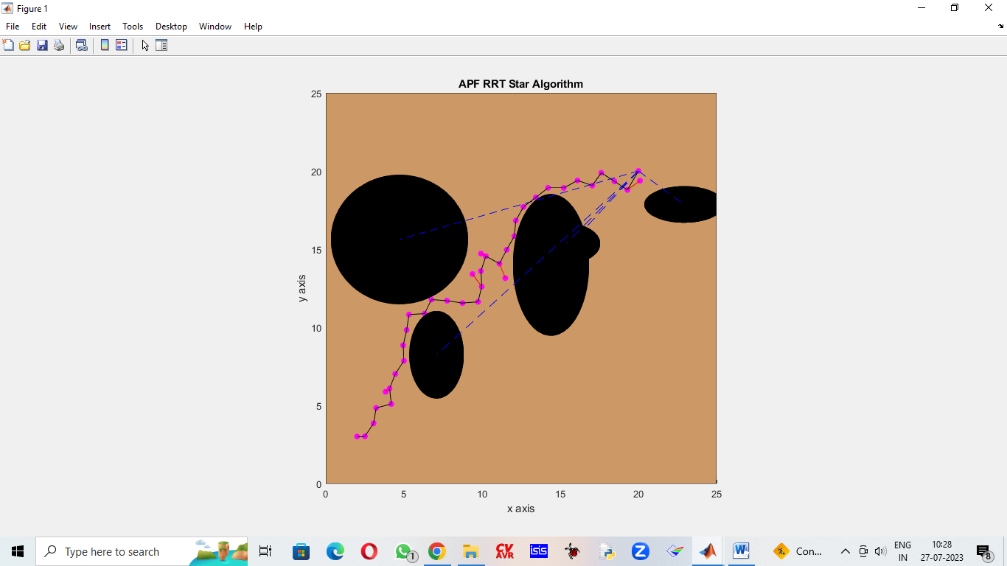

Iterations : 36

Distance Travelled : 31.9008

Time Taken : 13.1941